**Dashboard- Malaria in Africa**

**Insight 1# Namibia was able to control malaria**

If we click on Namibia we can see a column chart adjacent which shows the no of deaths in Namibia from 2001-2014 and as we can see the no of deaths has been drastically gone down from 1750 in 2001 to around 50 in 2014.

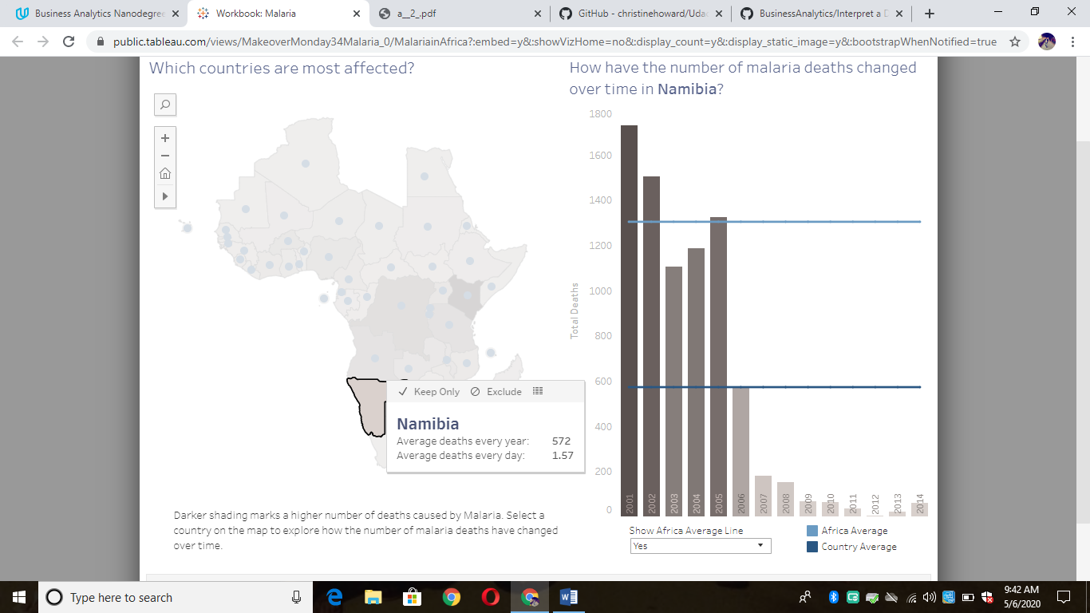

**Insight 2 # Death rate is below avg African death rate in Kenya in 2014.**

If we click on Kenya from the column chart we can see that no. of death in 2000 from malaria was around 49 k which is way above avg African deaths but in 2014 it is less than 1 k which is below the avg death rate.

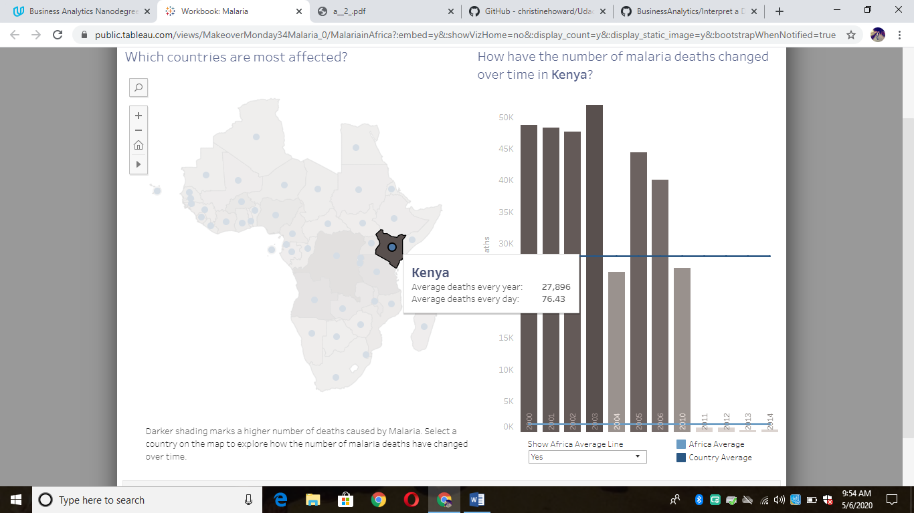

**Insight 3# Algeria is malaria free country**

If we click on Algeria we can see that avg deaths every day is 0 and as well as we can see that from the column chart as well that death rate in Algeria is almost 0 ,Hence we can say that Algeria is malaria free country.

